Do Retail Trading Strategies Hold Statistical Edge?
A Quantitative Backtesting Investigation into ORB and Liquidity Sweep Concepts on NASDAQ-100
Ray Kurhasaj
github.com/raykurhasaj12
Quantitative Research Project — 2026

Table of Contents
Table of Contents 2
My Story: Why I Am Creating This Project 3
History of Market Inefficiencies 3
The Grossman-Stiglitz Paradox (1980) 4
Retail Traders and Profitability 4
Why Retail Traders Cannot Compete 4
The Opening Range Breakout Strategy (ORB) 5
Key Liquidity Highs and Lows 5
Hypothesis: What We Are Testing 5
Backtesting Framework 6
Data and Timeframe 6
Different Variations of Our ORB Strategy 6
Setup 1: Immediate 5-Minute Breakout, Entry Candle Stop 6
Setup 2: 5-Minute Breakout, Midpoint Stop 7
Setup 3: 5-Minute Retest, Midpoint Stop 7
Setup 4: Immediate 1-Minute Breakout, Midpoint Stop 7
ORB Hypothesis 7
Liquidity Sweep Setups 10
Setup 1: Previous Day High/Low Reversal Model 10
Previous Day Low and High Liquidity Reversal Results 10
Interpretation of Our Results 10
Liquidity Continuation Model 11
Would This Strategy Be Profitable? 12
Monte Carlo Simulation Test 12
Trade-Order Permutation Test 13
Random-Entry Monte Carlo Test 13
Overfitting and Data Bias 15
Final Verdict 17
Limitations 18

My Story: Why I Am Creating This Project
For the past two years I have developed a strong interest in markets. Whether this is sport markets, crypto markets or financial markets, they continue to interest me. First, I started with sport markets — I am a regular sport watcher, and I have been for my whole life (21 years). I thought this experience would offer me advantages to exploit these markets. I initially assumed bookies made their money from uninformed customers who didn’t know much but just loved to gamble, but what I came to find out was bookies win based on pure maths — either by putting odds in their favour or blocking customers who were able to be profitable over the long run. This led me to learning about financial markets.
April 2025 is when I first started testing the markets. This was on demo accounts using strategies that I would find online, testing them day to day to see if I could make profits. I also would backtest my strategies to see if they were profitable over previous years. The problem with demo accounts and backtesting is that they don’t contain the pressure of live trading with real capital. I found financial markets to be more consistent and interpretable compared to sport markets. I felt like the markets had a pattern which is possible to exploit.
I was able to pass a Topstep funded account in November. Only 5% of customers ever pass funded accounts. Funded accounts are platforms which allow you to trade under restriction with demo money; if you are able to be profitable, they give you a cut of profits. Unfortunately, I couldn’t receive profits and lost the account. This made me believe that the only reason I passed was due to a “period of favourable variance rather than genuine edge.” Institutions have huge sample sizes which give them confidence their strategy works. As a maths graduate, I realised that unless I can statistically prove a strategy works, I will not continue to trade. This led me to building this project: finding out whether commonly taught retail strategies do work, and whether it is possible to exploit market inefficiencies.

History of Market Inefficiencies
A market in which prices always fully reflect available information is called efficient. Fama suggested the weak form, where prices reflect all past prices and volume data. The implication of this is that chart patterns and price levels cannot generate consistent excess returns — a strategy based on price patterns alone is essentially a challenge to this form of efficiency, which is exactly what our strategy directly tests. He also suggested the semi-strong form: prices reflect all publicly available information (earnings reports, news, etc.), implying that fundamental analysis cannot beat the market either. Fama argued he found strong empirical support for these conclusions, testing this using autocorrelation analysis on daily stock returns and finding correlations statistically indistinguishable from zero — suggesting past prices carry no predictive power over future returns. Fama formalised this as the random walk model: if markets are efficient, price changes follow:
Pₜ = Pₜ₋₁ + μ + εₜ
where εₜ is random noise with mean zero.
Fama’s evidence wasn’t airtight, and later researchers found cracks. They suggested he faced data limitations, and that the random walk model holds reasonably well over short horizons, but less well over longer horizons. Subsequent research found systematic patterns at specific times — returns are anomalously high in January, on Fridays, and crucially, at the market open.

The Grossman-Stiglitz Paradox (1980)
If markets are perfectly efficient, prices will already reflect all information, meaning informed and uninformed traders earn identical returns. So why would anyone bother doing research or analysis? The answer is they wouldn’t — and that is the paradox. If nobody does research, information stops flowing into prices, prices stop being efficient, and the whole foundation collapses. Perfect efficiency is therefore self-defeating.

Retail Traders and Profitability
Institutional traders are professionals who trade large volumes on behalf of organisations like banks or hedge funds. Retail traders, by contrast, buy and sell securities for their personal accounts. The internet is filled with retail traders aggressively promoting their strategies and lifestyles to many vulnerable people. They offer online courses suggesting they are profitable and that their customers can be too — the problem is many of these traders have no statistical proof of this, offering promises without evidence.
Institutions are organisations with huge statistical models, technology, and — most importantly — large sample sizes, giving them confidence that they statistically make profits in the long run. Retail traders do not have these advantages, yet often promote their strategies with the same confidence, frequently proposing similar concepts. The objective of this project is to test whether these strategies and confluences provide statistical evidence of having an edge in the market.

Why Retail Traders Cannot Compete
Retail traders face structural disadvantages that make consistent profitability difficult. These disadvantages stem from three categories: information asymmetry, sample size limitations, and operational constraints.
Institutional traders have access to real-time data and research. Retail traders face latency delays and less reliable data feeds. Finding adequate data proved unexpectedly difficult for this project — from unreliable APIs to limiting datasets, this was one of the greatest struggles I encountered. I needed data with a sample size large enough to find statistical evidence, across enough timeframes to test the strategies. Paywalls and unclear API documentation restricted my progress. Fortunately, I was eventually able to find a CSV file containing 10 years of NASDAQ data to test on. This experience highlights a crucial barrier: before a retail trader can even test whether a strategy works, they must overcome data access problems that institutions solve with a single purchasing decision.
In this project we generated approximately 1,280 trades. An institutional trader tests hundreds of variations across dozens of markets, timeframes, and asset classes simultaneously, generating millions of datapoints. With 1,280 trades, a 55%-win rate can easily be due to random variance; with one million trades, even a 51%-win rate is statistically significant (at 1:1 Risk to reward). Retail traders lack the sample sizes needed to confidently separate signal from noise.
Institutions have dedicated risk management, compliance, and execution teams. A retail trader must manage all of this alone, while maintaining discipline under emotional stress. Slippage, commissions, and execution failures compound losses.
The core reason retail traders fail is that they lack the statistical framework to know whether their strategy works. Without validating a strategy properly, a retail trader cannot distinguish between genuine edge and lucky variance.

The Opening Range Breakout Strategy (ORB)
This is a strategy many retail traders use. We are going to test whether there is statistical evidence this confluence has an edge. The setup defines the opening range as the high and low established during a specific window — commonly the 15-minute candle from 9:30 to 9:45 AM ET, the New York open, where the most volume and volatility often occur. The strategy then takes a directional position when price subsequently breaks beyond this range: long on a break above the range, short on a break below. The high and low of this window are argued to represent meaningful battle lines between supply and demand; a subsequent break of either level is interpreted as one side decisively overwhelming the other.
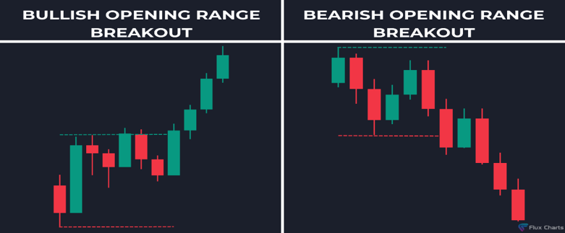

Key Liquidity Highs and Lows
Key prices such as the previous day’s highs and lows, as well as session extremes (Asian and London session highs and lows), accumulate pending buy and sell orders. These are known as liquidity pools. A liquidity sweep occurs when price aggressively moves beyond one of these key levels, triggering stop-loss orders beyond the level. This sweep often reverses quickly as the initial flush of stops exhausts and market structure reasserts itself. We are going to test whether the previous-day-high/low liquidity pool contains any exploitable information.

Hypothesis: What We Are Testing
Our null hypothesis is that no strategy has a genuine edge — is any profitable in the long term? To reject this null hypothesis, we look at the following rejection criteria:
- Positive expectancy: (Win rate × average win) − (Loss rate × average loss) > 0
- Outperforms a simple buy-and-hold strategy
- Maximum drawdown < 25% of initial capital (treated as the acceptable risk threshold)
- Return / Drawdown ratio > 1.0 (total profit exceeds the worst peak-to-trough loss)

Backtesting Framework

Data and Timeframe
All historical data is sourced from Kaggle (NASDAQ-100, minute-by-minute OHLCV data, 2016–2025). Data is filtered to 2020–2024, time-zone adjusted to New York time, and cleaned to remove non-trading days.
All testing is performed over the same window: 2nd January 2020 to 31st December 2024, a five-year period — for a retail trader, a relatively large sample. For each strategy we maintain a fixed risk rate per trade (1% of entry price per trade), allowing easy comparison of results across the orb strategy:
Position size = (Entry price × 0.01) / Distance to stop loss
When moving onto our liquidity setups we change our risk 1% of current account capital. This is because it allowed us to compare our out of sample results later into the project.
Stop losses are defined at a clear area or price point, while take profits are calculated to represent our required risk-to-reward ratios. We use 1:1, 2:1, and 3:1 risk-to-reward ratios across our studies to see how results vary.

Different Variations of Our ORB Strategy
Rather than testing a single fixed implementation of ORB, this study examines four variations that isolate specific entry, stop-loss, and take-profit decisions, to see how each alters our results. All setups use the 15-minute opening range, differing in:
- Entry trigger granularity (5-minute vs. 1-minute candle)
- Entry type (immediate breakout vs. retest of range boundary)
- Stop-loss placement (low of entry candle vs. midpoint of range)

Setup 1: Immediate 5-Minute Breakout, Entry Candle Stop
- Entry trigger: close of a 5-minute candle
- Stop loss: low of the 5-minute entry candle
- Take profit: calculated to adjust for respective risk to reward ratios

Setup 2: 5-Minute Breakout, Midpoint Stop
- Entry trigger: close of a 5-minute candle
- Stop loss: midpoint of the opening range
- Take profit: varied across risk-to-reward ratios

Setup 3: 5-Minute Retest, Midpoint Stop
- Entry trigger: a 5-minute candle closes back inside the opening range, then the next 5-minute candle closes back outside the range
- Stop loss: midpoint of the opening range high–low
- Take profit: calculated to adjust for respective risk to reward ratios

Setup 4: Immediate 1-Minute Breakout, Midpoint Stop
- Entry trigger: close of a 1-minute candle beyond the opening range high/low
- Stop loss: midpoint of the opening range
- Take profit: calculated to adjust for respective risk to reward ratios
With all these setups we keep the stop loss methodology fixed within each variant but alter the take-profit distance to test whether risk-to-reward changes the result.

ORB Hypothesis
The null hypothesis is that none of these four ORB variations generate returns statistically distinguishable from zero when tested on NASDAQ over the period 2020-01-02 to 2024-12-31, after accounting for multiple comparison correction. A rejection of the null hypothesis would require a variant showing positive expectancy, a Sharpe ratio greater than 1, and statistical significance under Monte Carlo permutation testing — suggesting a genuine edge in isolation.

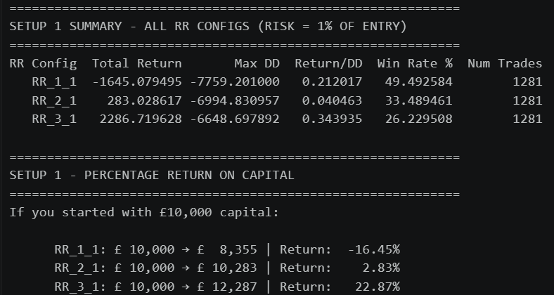
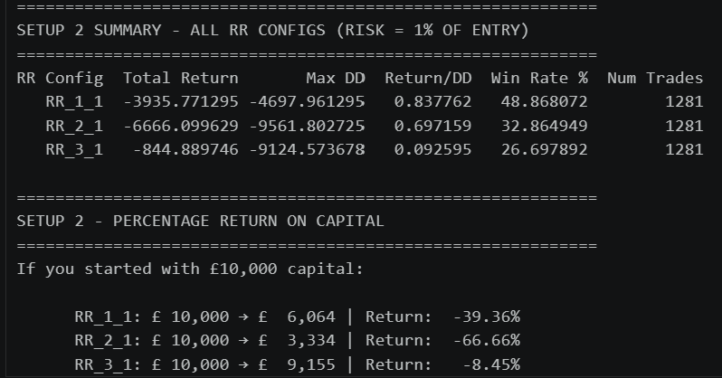
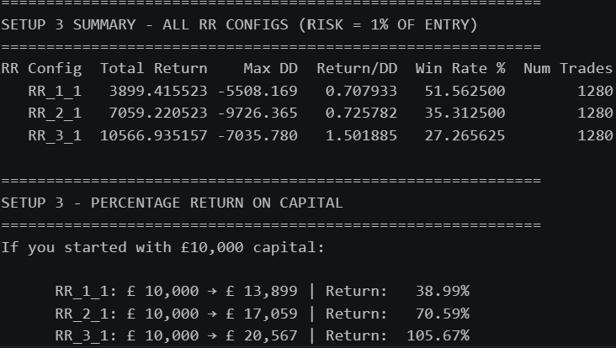
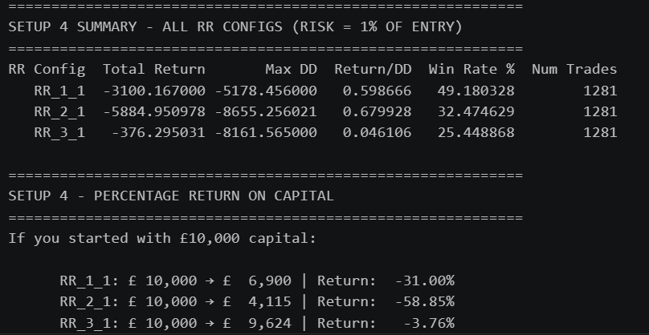
Figure 1–5. ORB strategy results across all four setup variations and risk-to-reward configurations.
From our results, we can see two profitable variations of our ORB strategy: setup 1 operating at a risk-to-reward of 3:1, and setup 3, which was profitable across all risk-to-reward ratios tested. We discarded the remaining variations and setups that were not profitable, as these showed no evidence of containing an edge. The retest method was the most effective showing profits at all respective RR. This indicates a simple alteration to a strategy can change it from being unprofitable to having a minor edge.
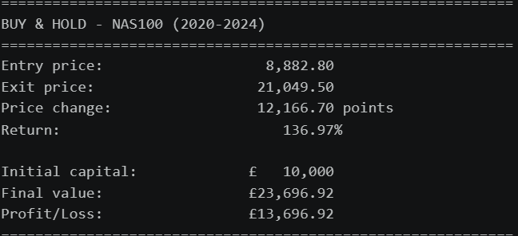
Figure 6. ORB strategy returns compared against a simple buy-and-hold benchmark.
However, when comparing these profitable strategies to a simple buy-and-hold approach over the same period, we found that they all underperformed buy-and-hold. This suggests that, instead of dedicating time and effort to the ORB strategy, an investor would have seen a greater return by simply buying and holding NASDAQ. There is not enough evidence to reject the null hypothesis. Our marginal gains could easily be due to chance. The fact it performed worse than a simple buy and hold gives us the conclusion the orb strategy does not have an edge in the market. Because of this I am not going to further analyse the ORB strategy.

Liquidity Sweep Setups

Setup 1: Previous Day High/Low Reversal Model
- Entry trigger: as soon as a key price level is hit
- Stop loss: tested at different fixed-point distances (5, 10, 15, 25 points from entry)
- Take profit: calculated for different risk-to-reward ratios
Setup 1 tests whether price is expected to reverse from these key levels. If the previous day’s high is hit, we place a short, expecting price to move lower; if the previous day’s low is hit, we place a long, expecting price to move higher.

Previous Day Low and High Liquidity Reversal Results
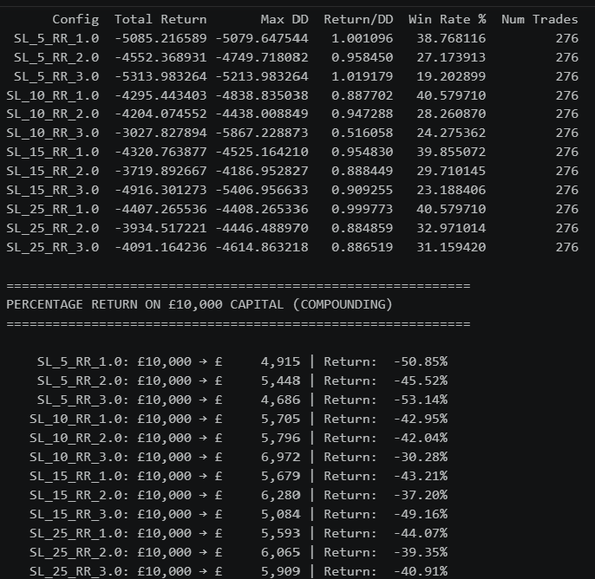
Figure 7. Liquidity reversal model results across all stop-loss and risk-to-reward configurations.

Interpretation of Our Results
From our results, the reversal model was unprofitable across every variation of the setup. Each configuration produced a negative percentage return, with win rates falling below the breakeven threshold required for its respective risk-to-reward ratio. This was a striking result given the prevalence of this idea in retail trading education. Studying this content leaves you to believe these price zones carry significant restriction — traders are advised to fade these “liquidity sweeps”, on the idea that markets sweep these zones before trending into the direction they actually intend to go, treating the swept level as a take-profit target on the expectation of an imminent reversal.
These findings led me to hypothesise what would happen if we instead applied a continuation model at these same price points. The results we obtained in setup 2 were striking.

Liquidity Continuation Model
Setup 2 tests whether price and trend are expected to continue from previous day highs and lows — we go long at the previous day’s high and short at the previous day’s low.
- Entry trigger: as soon as the previous day high or low is hit
- Stop loss: tested at different fixed-point distances (5, 10, 15, 25 points from entry)
- Take profit: calculated for different risk-to-reward ratios
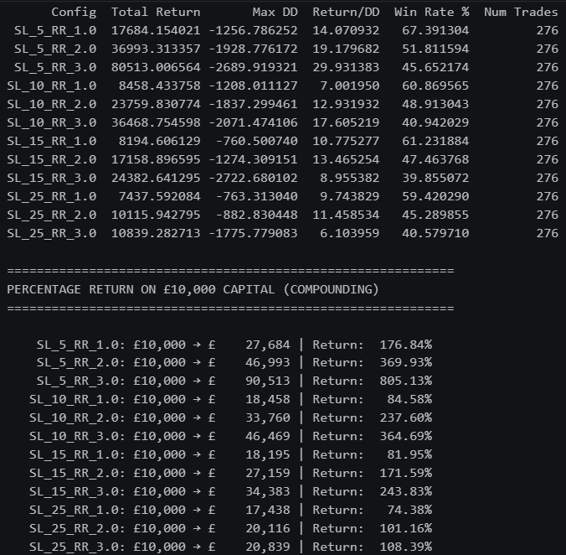
Figure 8. Liquidity continuation model results across all stop-loss and risk-to-reward configurations.
From our results, every variation of the continuation model was profitable. Seven of the twelve setups even outperformed a simple buy-and-hold strategy, suggesting a potential genuine edge in the market. Across each setup, increasing the risk-to-reward ratio increased total returns, suggesting that once a liquidity sweep occurs, it is more profitable to let the trade run toward its full target rather than taking profits early.
Our most profitable variation was a 5-point stop loss with a 3:1 risk-to-reward ratio, returning 805.13% across the five years — substantially outperforming the buy-and-hold return of 136.97%. Although this was the most profitable configuration, the variation I chose to further analyse was the 10-point stop loss at 3:1 risk-to-reward, which accumulated the third-highest return at 364.69%. I selected this configuration because a 5-point stop loss is unrealistically tight — trades risking only 5 points would be stopped out within seconds under live conditions. A 10-point stop gives a cleaner, more interpretable setup that better reflects how this strategy could realistically be traded.

Would This Strategy Be Profitable?
Our strategy took 276 trades, with 113 winning trades — a 40.94%-win rate, comfortably above the 25% breakeven win rate required at a 3:1 risk-to-reward ratio. Maximum drawdown also remained below 25% of capital, giving the strategy a margin to withstand adverse conditions. With 276 trades against approximately 1,300 trading days in the sample, the setup triggered roughly once per week — a frequency realistic to execute manually, and not so sparse that the sample becomes fragile.
We achieved a percentage return of 364.69%, with a Return/Max Drawdown ratio of 17.605, and a Sharpe ratio of 4.8085.
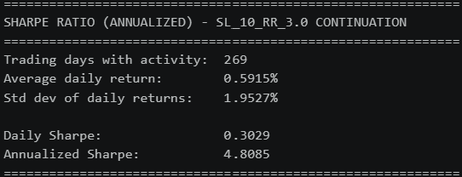
A Return/DD ratio of 17.605 means our total profit was over seventeen times larger than the worst peak-to-trough decline experienced.
This suggests the strategy can deliver strong returns while exposing the account to relatively minimal risk. A “solid” Return/DD ratio is often considered to be in the 1.5–3.0 range, so a result this positive warrants caution. Our Sharpe ratio of 4.8085 is similarly extraordinarily high — a Sharpe in the 1–2 range is generally considered good, so a figure this high suggests our strategy generates an unusually smooth and consistent return relative to its volatility. At face value, these results are positive but also suspicious; results this strong may reflect a measurement artefact, data bias, or overfitting to this specific historical period, rather than a robust and repeatable edge. We need to investigate further with Monte Carlo simulations and additional stress tests before drawing a confident conclusion.

Monte Carlo Simulation Test
Monte Carlo simulations use repeated random sampling to model a range of possible outcomes in a complex system.

Trade-Order Permutation Test
To determine whether our Return/Max Drawdown ratio is genuinely representative, we produced a Monte Carlo trade-order permutation simulation. This reshuffles our existing 276 trades into a random order and recomputes the resulting cumulative equity curve. We repeated this 1,000 times, each representing a plausible alternative history in which the same trades occurred in a different sequence. If our real trade result (17.605 Return/DD) sat in the extreme tail of this distribution, it would suggest our run benefited from an unusually fortunate sequence; if it sat comfortably within the middle of the distribution, this would support our risk metrics being a reasonably accurate reflection of the strategy’s true behaviour.
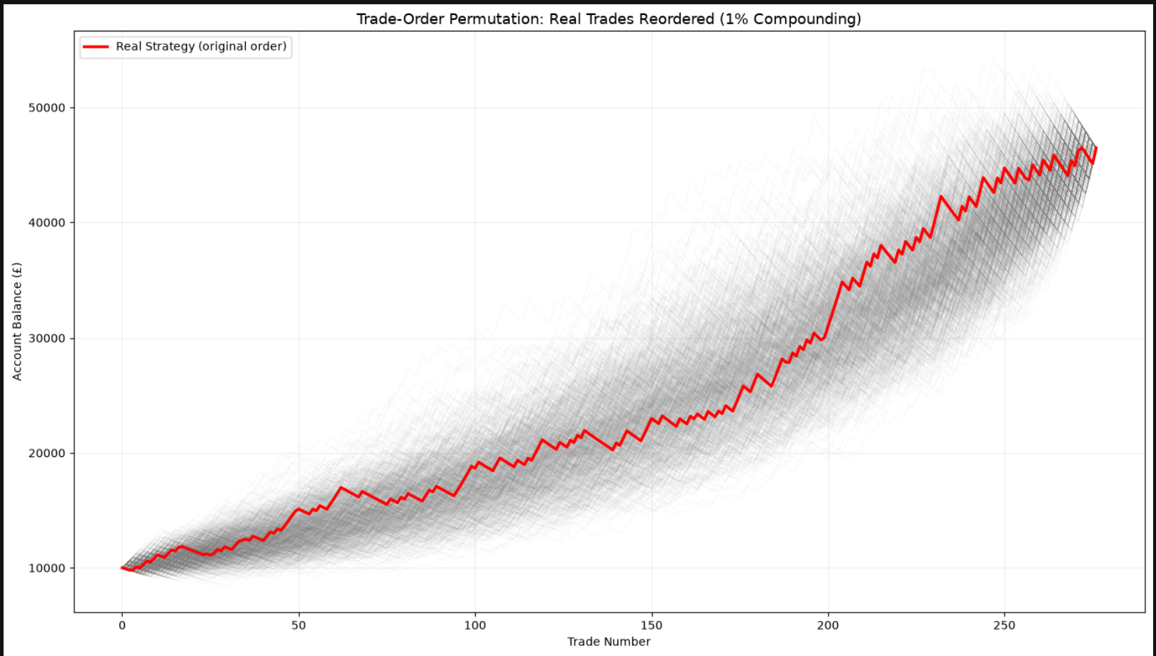
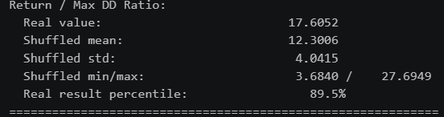
Figure 9–10. Trade-order permutation: real equity curve vs. 1,000 reshuffled orderings of the same trades.
Our real Return/DD ratio of 17.605 landed at the 89.5th percentile of the 1,000 simulated outcomes, with a shuffled mean of 12.3006. This suggests our result was within the upper, but not extreme, range of plausible outcomes — the low drawdown we experienced was not an outlier, lending credibility to the 17.605 figure.

Random-Entry Monte Carlo Test
We also wanted to test whether our strategy outperforms a sample of 1,000 possible random outcomes under a no-edge assumption. This addresses whether our strategy reflects genuine reasoning or simply luck — specifically, whether the previous day’s high and low contain exploitable information, or whether they behave no differently from any other price level on the chart.
Using the same five-year sample, instead of executing a trade at the previous day’s high or low, we picked a random price level during the New York session, placing a long or short randomly at this price with the same 10-point stop loss and 3:1 risk-to-reward ratio. Each simulation produced 276 randomly selected trading days, generating 276 trades, and we ran 1,000 such simulations. We set our threshold for statistical significance at the 95th percentile, equivalent to a p-value of 0.05 — meaning that if our real result outperformed at least 95% of the random simulations, there would be less than a 5% probability this occurred by chance alone.
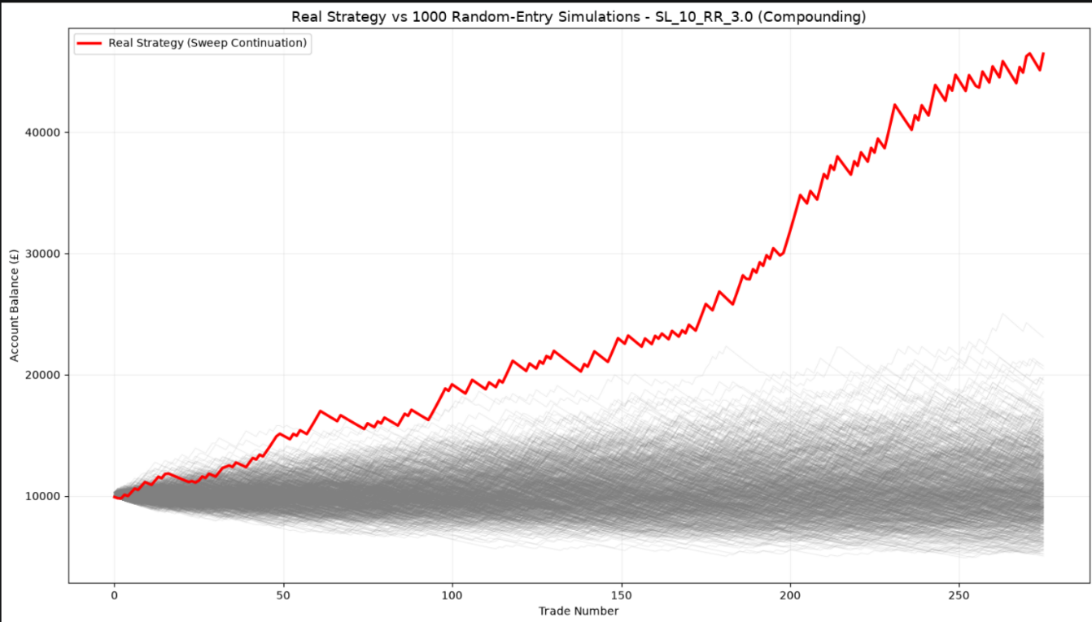
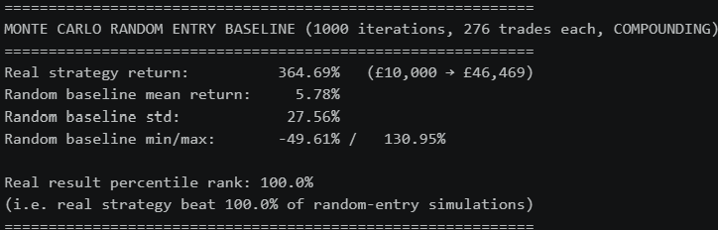
Figure 11–12. Real strategy equity curve vs. 1,000 random-entry simulations using identical exit mechanics.
These results are extremely compelling: there is clear evidence to suggest our strategy’s performance is not due to chance. Out of the 1,000 iterations, not one outcome produced a more profitable equity curve than our real strategy, giving a p-value of less than 0.001 — a less than 1% probability this occurred by luck. The mean return across all 1,000 random simulations was 5.78%, meaning an average portfolio of £10,000 would have grown to roughly £10,578 — a marginal gain.
This supports the retail trading hypothesis that previous day highs and lows contain exploitable information: our demonstrations show these price levels do not behave like randomly selected price levels during the New York session, but instead exhibit consistent, directional patterns. However, the way retail traders are taught to act on this information appears to be incorrect. Retail education often indicates these price levels carry high risk of reversal, whereas we have shown significant evidence to suggest the opposite: continuation, not reversal, occurs at these price levels. The practical implication is that traders acting on the conventional retail interpretation may be systematically trading against the actual statistical tendency of the market.

Overfitting and Data Bias
Overfitting occurs when a strategy appears profitable because its rules have been tuned, consciously or not, to the specific noise and coincidences of one particular historical dataset — rather than capturing a genuinely repeatable pattern in market behaviour. One way overfitting could arise in this project is through our selection of the best-performing stop-loss/risk-to-reward combination: this could simply be a coincidence that happened to align well with our specific dataset. Every time a strategy is selected from a search across multiple configurations, a bias towards overfitting is introduced.
Looking at our strategy’s equity curve, we do not believe this is obviously overfitted. An overfitted curve tends to be suspiciously smooth and steady throughout; our line is visibly jagged and choppy, with clear pullbacks — this is a realistic equity curve.
Data bias is the risk that our results are specific to a particular period of market history (2020–2024). This period was characterised by unusual conditions, including a strong post-pandemic bull run and historically loose monetary policy, which may not represent NASDAQ’s typical market behaviour. To test for this limitation, we applied our strategy, unchanged, to a separate out-of-sample period: 2016–2020. If we obtain similar results, this suggests our strategy is reasonably free of overfitting and data bias.
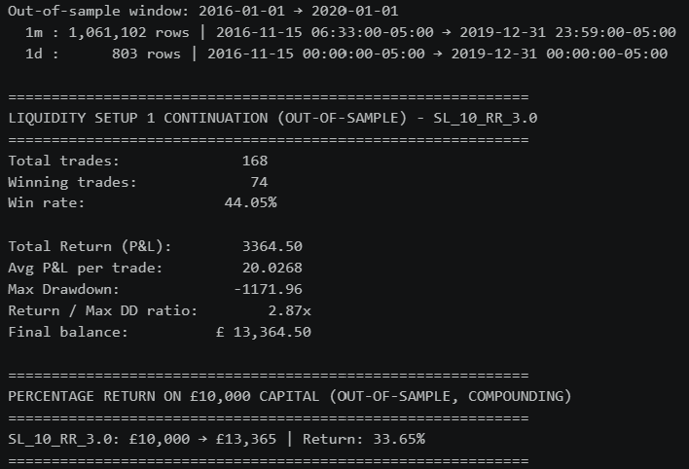
Figure 13. Out-of-sample results: SL_10_RR_3.0 continuation tested on 2016–2020 data.
At initial inspection, our win rate increased on the out-of-sample data, suggesting the strategy performed better — but the total return showed only a minimal increase, which raised suspicion that something was off. Investigating the trade log revealed that the majority of trades closed at the New York session close rather than reaching their take-profit level, meaning many trades never received their full intended payout.
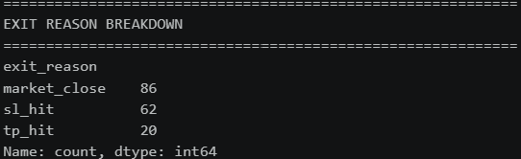
Figure 14. Trade log showing the high proportion of market-close exits in the out-of-sample period.
We attributed this to NASDAQ trading at approximately 5,000 points in 2016, compared to over 12,000 in our original 2020–2024 sample. At this lower price level, a fixed 10-point move represented a substantially larger proportional price change, requiring more time for price to travel the necessary distance to reach our take-profit before the session closed. Since our strategy was coded to forcefully close any open trade at the end of each New York session, a much higher proportion of trades were being cut short. To address this, we re-tested the strategy using a 5-point stop loss, sizing our risk distance more proportionally to the index’s value at the time. 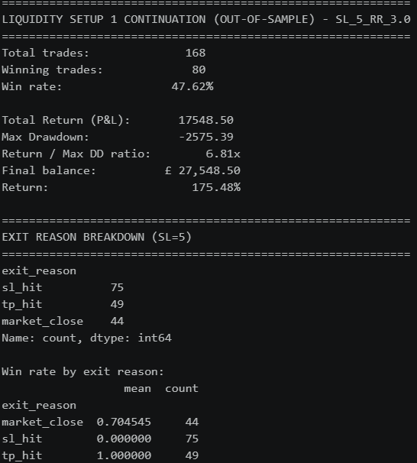

Figure 15. Out-of-sample results after recalibrating to a 5-point stop loss.
With the recalibrated stop loss, fewer trades ended at market close, and our win rate increased further to 47.62%. The strategy achieved a total return of £27,548 — outperforming buy-and-hold over the same period — with a Return/Max Drawdown ratio of 6.81. We did produce fewer trades so this may be why our returns were less. The strategy remained profitable on this out-of-sample dataset. Although it performed more strongly in 2020–2024, with higher returns and a larger Return/Max Drawdown ratio, we believe this is good evidence that our model was not significantly overfitted, nor primarily driven by data bias. The fundamental logic of the strategy — going long at the previous day’s high and short at the previous day’s low — shows evidence of a genuine, long-term edge. To maximise profits, it would be best to adapt the strategy’s parameters to current market conditions.

Final Verdict
This project set out to test whether claims made in retail trading education are backed by evidence and statistical rigour. We tested two confluences widely used by retail traders: the 15-minute opening range breakout (ORB) strategy, and previous day liquidity levels. Our null hypothesis was that neither concept contained genuinely exploitable information beyond what could be explained by chance.
For the ORB strategy, only a small number of variations were profitable, and when compared against a simple buy-and-hold benchmark, none represented a meaningful improvement worth the additional complexity and risk. We found insufficient evidence to reject our null hypothesis for the ORB strategy.
We then turned to previous day liquidity levels. If the retail narrative were correct, we would expect these significant price levels to produce a reversal pattern following a sweep. Testing this directly, we found that none of our reversal model variations were profitable, even after testing across multiple stop-loss distances and risk-to-reward ratios. What we found instead is that continuation, not reversal, is the better-supported behaviour at these same price levels.
We selected one continuation variation for further investigation, to determine whether its performance reflected a genuine statistical edge or could plausibly be attributed to chance. A Monte Carlo simulation using 1,000 random-entry baselines, holding all other parameters identical, produced a p-value of less than 0.001, with our real strategy outperforming every single random-entry simulation. This result also survived an out-of-sample test on 2016–2020 data — an unseen period the strategy had not been tuned or tested on — continuing to perform well and suggesting our results were not substantially affected by overfitting or data bias. We were able to successfully reject our null hypothesis and suggest there is significant evidence to conclude there is exploitable information at the previous day high and low price levels.
Our results indicate continuation strategies at these price levels are better supported by historical evidence than the reversal strategies typically promoted in retail trading education. This distinction matters beyond the purely academic: it suggests that some commonly taught retail trading concepts may correctly identify where the market behaves non-randomly, while being wrong about which direction that non-randomness favours.

Limitations
Although I have been critical of certain retail trading claims in this project, there are several important limitations we need to acknowledge.
Most retail traders are “discretionary” traders. A discretionary trader is one who, rather than deploying a strategy based purely on fixed statistical rules, makes trading decisions based on a combination of confluences and accumulated experience. In this project, we executed essentially the same rules-based trade automatically, hundreds of times, over a multi-year period, with code that ignored many other market conditions that may have been occurring at the time. Retail traders typically do not trade this way — instead, they trade manually, weighing many confluences together, with execution decisions shaped by factors such as time of day, price action, candle formations, and intuition built up through experience. Many of these decision processes are not easily codified, and a setup a discretionary trader executes on one occasion may be deliberately skipped on another, based on contextual judgement a backtest cannot replicate. This makes direct comparison between our systematic, rules-based backtest and real discretionary retail trading imperfect.
Although we provided evidence our continuation strategy was profitable in a backtest, market conditions can change substantially between backtested and a live forward-tested performance. A strategy that has worked historically does not necessarily continue to work going forward. Financial markets are dynamic, and as more participants identify and exploit a given pattern, that pattern’s edge can erode over time — a phenomenon sometimes referred to as alpha decay. Additionally, while our combined sample spans approximately nine years (2016–2024), and may seem substantial from a retail perspective, this would be considered a relatively short sample by institutional standards.
A further limitation is that we tested only two specific confluences out of the hundreds used across the retail trading community. Demonstrating that the ORB and reversal-based liquidity strategies lack a statistical edge is not conclusive evidence that all retail trading concepts are similarly unfounded. Our findings should be read as specific to the strategies tested, not as a blanket conclusion about retail trading education as a whole.

